1. member ===> member_id

title ===>title_id

title_copy ===> copy_id+title_id

rental===> book_date+copy_id+title_id

reservation ===> res_date+member_id+title_id

2.

|  |  |  |  |  |
| --- | --- | --- | --- | --- |
| Member | Title | Title_Copy | Rental | Reservation |
| Pk member_id | Pk title_id | Pk copy_id | Pk book_date | Pk res_date |
|  |  | Pk fk title_id | Pk fk copy_id | Pk fk member_id |
|  |  |  | Pk fk title_id | Pk fk title_id |

3.

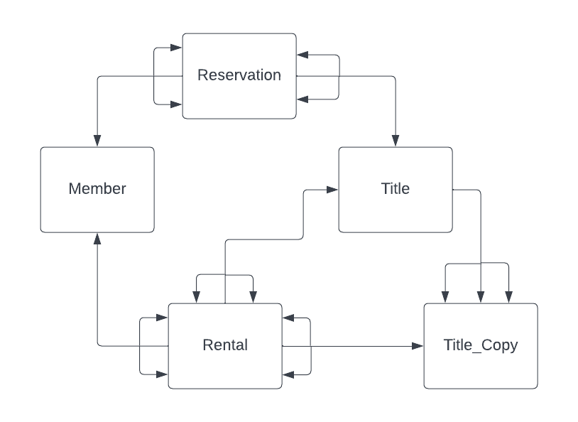

4.

select * from title

inner join rental using (title_id)

group by category

having count(*)= (select max(count(category)) from rental

inner join title using (title_id)

group by category)

select * from title a

inner join (select category from rental

inner join title using (title_id)

group by category

having count(*)==max(count(category))) maxCat

on a.category=maxCat.category

5.

select title from title t join(select title_id,copy_id from title_copy

minus

select title_id,copy_id from rentals r

right join title_copy t on r.title_id=t.tile_id

where exp_ret_date is null) sq on t.title=sq_title

6.

SELECT T.TITLE, C.COPY_ID, C.STATUS,

(CASE

WHEN ACT_RET_DATE IS NULL THEN ‘NOT AVAILABLE’

ELSE ‘AVAILABLE’

END AS STATUS_CORECT)

FROM TITLE T

INNER JOIN TITLE_COPY C ON T.TITLE_ID=C.TITLE_ID

LEFT JOIN RENTAL R ON R.TITLU_ID=T.TITLU_ID

7.

A. SELECT COUNT(*)

FROM (SELECT T.TITLE,C.COPY_ID,STATUS,

(CASE

WHEN ACT_RET_DATE IS NULL THEN ‘NOT AVAILABLE’

ELSE ‘AVAILABLE’

END AS STATUS_CORECT)

FROM TITLE T,TITLE_COPY C WHERE T.TILE_ID=C.TITLE_ID

WHERE STATUS!=STATUS_CORECT

B. CREATE TABLE TITLE_COPY_*** AS SELECT * FROM TITLE_COPY;

UPDATE TITLE_COPY_*** SET STATUS= (CASE

WHEN ACT_RET_DATE IS NULL THEN ‘NOT AVAILABLE’

ELSE ‘AVAILABLE’

END AS STATUS_CORECT)

8. SELECT

CASE

WHEN (SELECT COUNT(*) FROM RENTAL R

JOIN RESERVATION RES ON (R.MEMBER_ID=RES.MEMBER_ID AND R.TILE_ID=RES.TITLE_ID)

WHERE BOOK_DATE!=RES_DATE)>0

THEN ‘NU’

ELSE ‘DA’

END;

FROM DUAL

9. SELECT M.LAST_NAME,M.FIRST_NAME,T.TITLU,COUNT(T.TITLE_ID)

FROM MEMBER M

INNER JOIN RENTAL R ON (M.MEMBER_ID=R.MEMBER_ID)

INNER JOIN TITLE_COPY C ON (R.COPY_ID=C.COPY_ID AND C.TILE_ID=R.TITLE_ID)

INNER JOIN TITLE T ON (T.TITLE_ID=C.TITLE_ID)

GROUP BY T.TITLE_ID,T.TITLE,M.LAST_NAME,M.FIRST_NAME

10. select las_name, first_name, copy_id, cout(copy_id)

from membru m

inner join rental t on m.member_id= t.member_id

right join title_copy tc on t.copy_id=tc.copy_id

group by last_name,first_name,copy_id

11. SELECT TITLE,C.STATUS

FROM TITLE_COPY C

INNER JOIN TITLE T ON (T.TILE_ID=C.TITLE_ID)

WHERE C,COPY_ID=(SELECT COPY_ID

FROM RENTAL R

INNER JOIN TITLE_COPY C ON (R.COPY_ID=C.COPY_ID)

GROUP BY C.COPY_ID

ORDER BY COUNT(C.COPY_ID)DESC)

WHEN ROWNUM=1)